**Title:** **Object Recognition in Images**

**Abstract:**

Object Recognition is one of the important problems in the domain of Computer Vision. It has made great progress over the years because of the Machine Learning algorithms. The objective of this project is to build a model that classifies images accurately using a CIFAR-10 dataset. The CIFAR-10 dataset has 60000 32x32 color images with 10 classes, and there are 6000 images in each class. The dataset is divided into train and test with 50000 images in train dataset and 10000 images in the test dataset. The label classes in the dataset are: airplane, automobile, bird, cat, deer, dog, frog, horse, ship and truck.

**Domain of Study:** Classification algorithms in Object Recognition

**Algorithms:** I am looking to explore **k-NN, SVM** algorithms along with **Convolutional Neural Networks** on the CIFAR-10 image dataset.

**Importance of Algorithms in Real World:**

In the last 5 years or so, with the advent of self-driving cars, automobile industry started using Deep Learning techniques in various applications such as lane detection, road sign detection, signal detection, etc. Another example where Deep Learning techniques have been useful is Ebay, which started to let the customers to search for items with photos.

**Tools:** I am still not sure whether this image dataset fits well on the RAM of my laptop when I use CNN architectures. So, I am learning to use Amazon Web Services so that I can use the instances of AWS for this project. Along with that, I am trying to learn how to use TensorFlow and Keras on top of Python to implement the CNN architectures in a simpler way.

**Data Source:** <https://www.cs.toronto.edu/~kriz/cifar.html>

The CIFAR-10 dataset has 60000 32x32 color images with 10 classes, and there are 6000 images in each class. The dataset is divided into train and test with 50000 images in train dataset and 10000 images in the test dataset. The label classes in the dataset are: airplane, automobile, bird, cat, deer, dog, frog, horse, ship and truck. I wish to separate 5000 images from the train dataset and use it as a validation dataset. So, I want to use 45000 images as train data, 5000 images as validation data and the remaining 10000 images as test data.

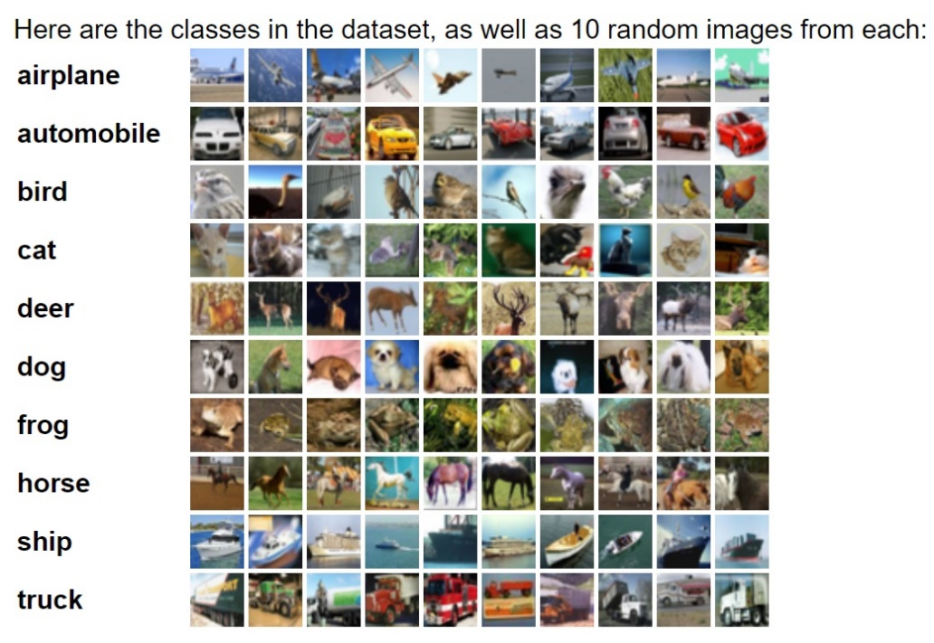

Source: <https://www.cs.toronto.edu/~kriz/cifar.html>

**Data Manipulation:**

I would like to increase the train dataset by using a technique called data augmentation in order to improve the performance. The intuition is to take the CIFAR training dataset and augment it with various types of transformations such as rotation, rescaling, horizontal or vertical flipping, etc.

**References:**

<https://www.cs.toronto.edu/~kriz/cifar.html>

<https://www.kaggle.com/c/cifar-10>

<http://cs231n.stanford.edu/>

<http://www.deeplearningbook.org/>

<http://tensorflowbook.com/>

<https://keras.io/>

<https://www.oreilly.com/ideas/solving-real-world-business-problems-with-computer-vision>

https://venturebeat.com/2017/07/26/ebay-to-use-computer-vision-to-help-you-search-for-items-using-photos/

**Project URL:**

<https://medium.com/@dinnuv/object-recognition-in-images-using-deep-learning-7b1cefccd0ab>

**Graphics:** I want to use Confusion Matrix tables, Accuracy plots to describe the results.

**Challenges:** At present, I am trying to get an instance on AWS on my Windows. I am finding it difficult and getting errors. I had to set up Jupyter to work on my local browser. But, I am successful in installing these software on my PC and so have started on working on the project locally. It took around 6 hours to model a simple Convolutional Neural Network with 25 epochs (iterations).